Evaluating U-Net Segmentation in Vgg16-Based Leukemia Classification: A Comparative Study

Rizky Vera Oktarina¹*, Afu Ichsan Pradana¹, Vihi Atina¹, Farahwahida Mohd²

¹Department of Informatics Engineering, Faculty of Computer Science, Universitas Duta Bangsa Surakarta, Indonesia
²Malaysian Institute of Information Technology, Universiti Kuala Lumpur, Kuala Lumpur, Malaysia

Email: 220103074@mhs.udb.ac.id*

Submitted: 17 June 2026 Reviewed: 28 July 2026 Accepted: 11 August 2026

ABSTRACT

Background: Leukemia is a malignant hematological disorder characterized by abnormal proliferation of white blood cells (WBCs), affecting over 474,000 patients globally each year, with manual diagnosis limited by inter-observer variability of up to 40%. Objective: This study evaluates whether U-Net-based WBC segmentation improves leukemia classification by comparing three configurations: VGG16 on original images, VGG16 with U-Net-predicted masks, and VGG16 with ground truth masks. Methods: A total of 3,256 ALL microscopic blood smear images were divided into training, validation, and testing sets (70:10:20). U-Net was trained using a combined Binary Cross-Entropy and Dice loss, and the segmentation outputs were used as inputs for VGG16 classification. Performance was evaluated using DSC, IoU, accuracy, precision, recall, F1-score, and AUC-ROC. Results: U-Net achieved a DSC of 0.7885 and an IoU of 0.7134. VGG16 with U-Net masks achieved 98.62% accuracy (AUC 0.9958), while VGG16 with ground truth masks achieved 98.31%. The baseline VGG16 achieved the highest performance with 99.69% accuracy (AUC 0.9999). Conclusion: Explicit segmentation did not improve classification performance for the dataset used in this study and may introduce unnecessary computational overhead when discriminative features are already preserved in the original images. Suggestion: Future studies should evaluate heterogeneous datasets and advanced segmentation architectures to further investigate the contribution of segmentation to leukemia classification.

Keywords: Comparative Study; Convolutional Neural Network; U-Net; VGG16; White Blood Cell

INTRODUCTION
Leukemia is a malignant hematological disorder characterized by abnormal proliferation of white blood cells (1), requiring rapid and accurate diagnosis for effective treatment (2). Manual microscopic examination by pathologists remains the gold standard for diagnosis; however, it is inherently subjective and limited by fatigue and time constraints (3). To address these limitations, various automated approaches have been proposed, including hybrid machine learning methods that combine traditional (4) classifiers with optimization techniques (5).
Convolutional Neural Networks (CNNs) (6) have become the dominant approach in leukemia classification (7), with architectures such as VGG16 (8), ResNet, and DenseNet demonstrating strong capability in extracting discriminative features from blood smear images (9). Pretrained models leveraging ImageNet weights are particularly effective due to their ability to capture hierarchical visual patterns transferable to medical imaging tasks. Nevertheless, challenges remain, especially in handling overlapping cells and variations in staining conditions (10).
To address these issues, segmentation-based approaches have been widely adopted. In particular, U-Net has gained popularity for medical image segmentation (11) due to its encoder-decoder structure with skip connections (12), which preserves spatial information and enables precise localization of regions of interest (13). By isolating white blood cells from the background (14), segmentation is generally expected to improve classification performance by reducing irrelevant background information. Previous studies have reported promising segmentation results, with Dice coefficients exceeding 0.85 in white blood cell segmentation tasks (13).
However, the effectiveness of segmentation in improving classification performance remains inconclusive (15). While segmentation is intuitively beneficial, its impact may depend on dataset characteristics, particularly when the visual distinction between classes is already prominent. Existing studies often assume that segmentation universally enhances classification accuracy, without thoroughly examining scenarios where global morphological differences are sufficient for discrimination. Moreover, few studies distinguish whether any observed performance differences arise from segmentation quality or from the masking process itself.
Therefore, this study aims to critically evaluate the actual contribution of U-Net-based WBC segmentation in leukemia classification by comparing three experimental configurations: (1) a VGG16 (16) model trained directly on original blood smear images (baseline), (2) a VGG16 model receiving images pre-processed with U-Net-predicted segmentation masks, and (3) a VGG16 model using ground truth segmentation masks as an upper-bound performance reference. The third configuration enables a more rigorous evaluation by distinguishing the influence of segmentation quality from the intrinsic effect of the masking process on classification performance. Specifically, this study investigates whether U-Net (17) segmentation improves leukemia classification and whether any observed performance differences arise from segmentation quality or from the masking process itself. The findings are expected to provide practical insights for developing efficient and reliable leukemia computer-aided diagnostic (CAD) systems applicable to clinical settings (18).
The remainder of this paper is organized as follows: Section II describes the research methodology, including dataset preparation, segmentation, and classification models. Section III presents the experimental results and discussion. Finally, Section IV concludes the study and outlines future work.

METHODS
This study employs a deep learning pipeline for leukemia (19) classification using microscopic blood smear images (20). The methodology consists of dataset preparation, preprocessing, U-Net-based segmentation, VGG16-based classification, and performance evaluation (21). The U-Net architecture follows the encoder-decoder design principle, which has been formally analyzed and unified across various configurations (22). The overall process is designed to ensure a fair comparison between segmented and non-segmented approaches while preventing data leakage (23).
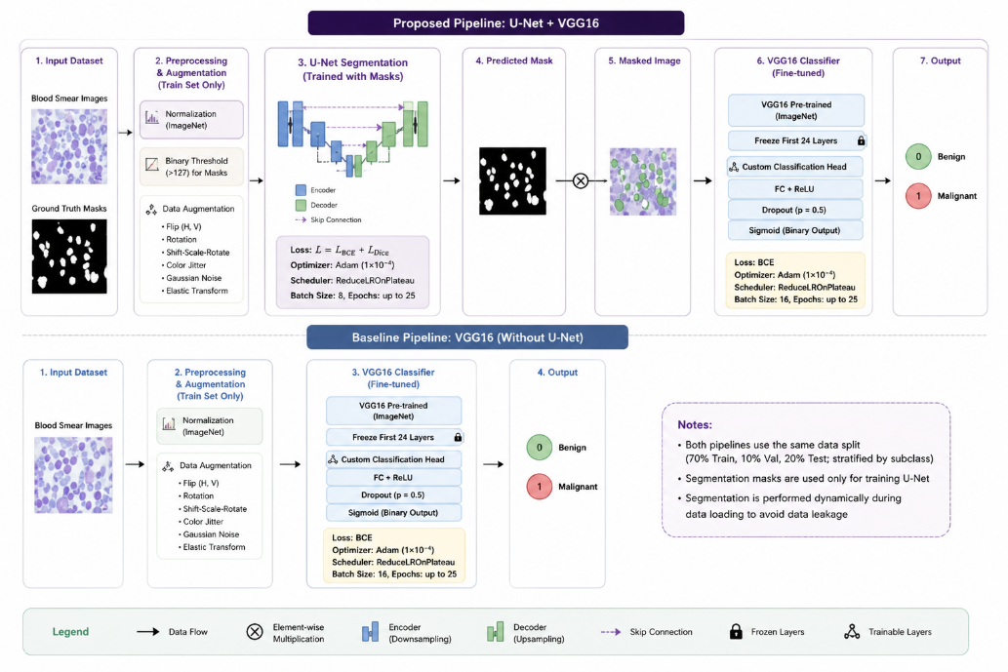
Figure 1. Block diagram of the proposed U-Net+VGG16 pipeline and the baseline VGG16 model

Dataset
The dataset used in this study is a publicly available Acute Lymphoblastic Leukemia (ALL) image dataset obtained from Kaggle (24), consisting of 3,256 microscopic blood smear images in JPG format with a resolution of 224×224 pixels. The dataset is categorized into four classes: Benign (504 images) and three malignant subtypes—Early (985 images), Pre (963 images), and Pro (804 images).
For classification purposes, the dataset was reformulated into a binary classification problem. Benign images were labeled as class 0, while all malignant subtypes were grouped as class 1. This transformation simplifies the classification task and enables direct comparison between different modeling approaches (25).
The dataset also includes corresponding ground truth segmentation masks, which were used exclusively for training and evaluating the U-Net model.
A single stratified split (based on subclass distribution) was applied into training (70%, n = 2,279), validation (10%, n = 325), and testing (20%, n = 652). This split was performed once and consistently reused across all models to ensure fair evaluation and to prevent data leakage. A fixed random seed (42) was used to ensure reproducibility.

Preprocessing and Augmentation
All images were originally provided in 224×224 resolution, which matches the input requirement of the VGG16 architecture; therefore (26), no resizing was required. Images were normalized using ImageNet statistics with mean values of [0.485, 0.456, 0.406] and standard deviations of [0.229, 0.224, 0.225].
For segmentation, ground truth masks were converted into strict binary format using a threshold value of 127 to mitigate JPG compression artifacts. This step ensures cleaner supervision signals and improves segmentation performance.
Data augmentation was applied only to the training set to improve model generalization. The augmentation techniques included horizontal and vertical flipping, random rotation (3), shift-scale-rotate transformation, color jittering, Gaussian noise, and elastic deformation. For the segmentation model, all augmentations were applied jointly to both images and corresponding masks to preserve spatial alignment.

U-Net Segmentation Model
The segmentation stage aims to isolate white blood cell (WBC) regions from the background in microscopic blood smear images. The process begins with feeding the preprocessed original image into the trained U-Net model, which produces a binary segmentation mask. This predicted mask is then applied element-wise to the original image, effectively preserving only the WBC regions while suppressing background noise. The resulting masked image is subsequently used as input for the VGG16 classification model. This segmentation-then-classification pipeline ensures that the classifier focuses exclusively on morphologically relevant cellular regions. To ensure fair comparison, ground truth masks provided in the dataset were also independently applied to original images using the same masking procedure, serving as an upper-bound reference for evaluating the impact of segmentation quality on classification performance.
The segmentation model is based on the U-Net architecture, which follows an encoder-decoder structure with skip connections (12). This configuration follows the standard U-Net architecture widely used in medical image segmentation, with the addition of Batch Normalization after each convolutional layer to stabilize training. The encoder consists of four levels with feature channels of [64, 128, 256, 512], followed by a bottleneck layer with 1,024 filters. The decoder mirrors the encoder structure using transposed convolution for upsampling. Each convolutional block contains two 3×3 convolution layers followed by Batch Normalization and ReLU activation. A final 1×1 convolution layer with sigmoid activation is used to produce binary segmentation masks.
The model was trained using a combined loss function defined as:

L = L_{BCE} + L_{Dice}
$L_{BCE}$
where LBCE ensures pixel-wise classification accuracy and LDice optimizes the overlap between predicted and ground truth masks, particularly addressing class imbalance. The model was optimized using the Adam optimizer with a learning rate of 1×10⁻⁴ and a ReduceLROnPlateau scheduler (patience = 3, factor = 0.5). Training was conducted for up to 25 epochs with a batch size of 8.

VGG16 Classification Model
The classification model utilizes the VGG16 architecture pre-trained on ImageNet for transfer learning (27). The original fully connected layers were replaced with a custom classification head consisting of a fully connected layer with ReLU activation, followed by dropout (p = 0.5) and a final sigmoid layer for binary classification. To retain low-level feature representations, the first 24 layers were frozen, while the remaining layers were fine-tuned during training.
Binary Cross-Entropy (BCE) loss was used as the objective function. The model was optimized using the Adam optimizer with a learning rate of 1×10⁻⁴, along with a ReduceLROnPlateau scheduler. Training was performed for a maximum of 25 epochs with a batch size of 16. However, the model converged earlier, and training effectively stopped at epoch 16 as no significant improvement in validation performance was observed. This indicates stable learning and efficient convergence of the model.

Experiment Setup
Two experimental configurations were designed to evaluate the impact of segmentation on classification performance. In the proposed model, the trained U-Net was used to generate segmentation masks (28), which were applied to the original images to extract regions of interest (29). The resulting masked images were then used as input to the VGG16 classifier (30). In contrast, the baseline model employed the same VGG16 architecture but was trained and evaluated directly on the original images without segmentation.
Both configurations used identical data splits, preprocessing steps, augmentation strategies, and training parameters to ensure a fair and unbiased comparison. The U-Net model was trained exclusively on the training split. After training was completed, the fixed U-Net weights were used to generate predicted masks dynamically during data loading for the training, validation, and test sets. The ground truth masks of the validation and test sets were never seen by the U-Net during its training, thereby strictly preventing data leakage.
All experiments were conducted using Google Colab with GPU acceleration (NVIDIA T4) and implemented using the PyTorch framework.

Evaluation Metrics
Segmentation performance was evaluated using the Dice Similarity Coefficient (DSC) and Intersection over Union (IoU). Classification performance was evaluated using Accuracy, Precision, Recall, F1-Score, and Area Under the Receiver Operating Characteristic Curve (AUC-ROC). The AUC-ROC metric was used to assess the model's ability to distinguish between classes across different classification thresholds.
All evaluation metrics were computed on the held-out test set.

RESULTS
U-Net Segmentation Performance
The U-Net model was trained for up to 25 epochs and demonstrated stable convergence during training. The validation Dice score increased progressively from 0.7682 in the initial epoch to approximately 0.9303 at the final epoch, while the validation loss decreased significantly from 0.7323 to 0.1147. The training curves indicate stable optimization behavior, with no significant signs of overfitting observed.
The best-performing model was obtained at the final epoch, where the highest validation Dice score and lowest validation loss were achieved simultaneously. On the test set, the model achieved a mean Dice Similarity Coefficient (DSC) of 0.7885 and a mean Intersection over Union (IoU) of 0.7134, as presented in Table 1

Table 1. U-Net Segmentation Performance on Test Set
Metric | Score
Dice Similarity Coefficient (DSC) | 0.7885
Intersection over Union (IoU) | 0.7134

The segmentation process follows three sequential stages. First, the original blood smear image is fed into the trained U-Net model to generate a binary predicted mask. Second, both the predicted mask and the ground truth mask are independently applied element-wise to the original image, producing a U-Net masked image and a ground truth masked image, respectively. Third, the U-Net masked image serves as the actual input to the VGG16 classification model, while the ground truth masked image serves as an upper-bound reference. Representative examples of all five outputs across four test samples are shown in Figure 2, illustrating the original image, ground truth mask, ground truth masked image, U-Net predicted mask (with per-sample Dice score), and U-Net masked image.
The obtained DSC of 0.7885 indicates that the model achieves reasonably accurate segmentation of WBC regions across different morphological variations. As visible in Figure 2, the U-Net masked images successfully isolate WBC structures while suppressing background erythrocytes, producing inputs that focus the classifier on relevant cellular regions. The ground truth masked images demonstrate the ideal segmentation outcome that represents the upper-bound reference for classification.
Visually, the U-Net successfully segmented the majority of white blood cells with clear boundaries, as shown in Figure 2. However, minor under-segmentation and over-segmentation were observed in some cases, particularly when cells were overlapping or when the staining intensity varied significantly. Despite these imperfections, the resulting U-Net masked images still retained the essential morphological features of the leukocytes required for classification.
However, some test samples containing predominantly erythrocytes with minimal or absent WBCs produced near-zero Dice scores, which reduced the overall average. This behavior is expected in Dice-based evaluation when ground truth masks contain very small or empty target regions, and reflects dataset characteristics rather than fundamental model limitations (31).
A critical preprocessing step significantly improved segmentation performance. Applying binary thresholding (>127) to the ground truth masks addressed inconsistencies caused by JPG compression artifacts, which originally introduced grayscale values instead of strict binary labels. Without this correction, the model achieved only a DSC of 0.5764, compared to 0.7885 after thresholding, confirming the importance of clean supervision signals in segmentation training.
Overall, the segmentation results confirm that the U-Net was able to produce sufficiently accurate masks to isolate WBC regions, allowing a fair comparison between predicted and ground-truth segmented inputs in the subsequent classification experiments.

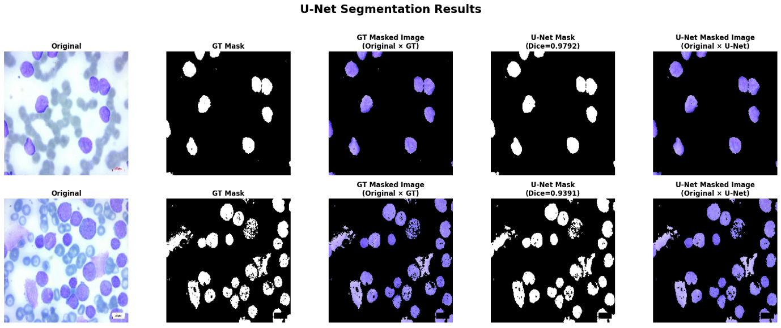
Figure 2. Sample of original images, ground truth mask, ground truth masked image, U-Net predicted mask, and U-Net masked image across two test samples.

Classification Result - VGG16 + U-Net
Prior to classification, each blood smear image was processed using the trained U-Net model to generate a binary segmentation mask. The predicted mask was then applied element-wise to the original image, producing a U-Net masked image that retained only the white blood cell (WBC) regions while suppressing background erythrocytes and other irrelevant regions. These masked images, illustrated in the fifth column of Figure 2, were used as the input to the VGG16 classification model. For comparison, ground truth masked images, shown in the third column of Figure 2, were generated by applying the same masking procedure to the manually annotated ground truth masks. These images served as an upper-bound reference for evaluating the influence of segmentation quality on classification performance.
Although training was set for a maximum of 25 epochs, the model converged earlier and effectively stopped improving after epoch 16 as validation performance stabilized. This early convergence can be attributed to several factors. First, the use of transfer learning with a pretrained VGG16 model allows the network to leverage previously learned features, reducing the amount of training required. Second, the dataset exhibits high visual separability, enabling faster learning of discriminative patterns. Additionally, validation loss fluctuations after epoch 12 indicate the onset of mild overfitting. The ReduceLROnPlateau scheduler further stabilized training by lowering the learning rate when performance plateaued.
The proposed pipeline combining U-Net segmentation and VGG16 classification achieved an overall accuracy of 98.62% on the test set, as presented in Table 2.

Table 2. Classification Performance of VGG16 + U-Net
Class | Precision | Recall | F1-Score | Support
Benign | 0.92 | 0.96 | 0.94 | 101
Malignant | 0.99 | 0.99 | 0.99 | 551
Accuracy | - | - | 0.9862 | 652
Weighted Avg | 0.98 | 0.99 | 0.9861 | 652

The model achieved an AUC-ROC of 0.9958, indicating excellent discriminative capability. The confusion matrix (Figure 3) shows that only 9 misclassifications occurred among the 652 test samples. The lower precision for the benign class (0.92) indicates that seven benign samples were incorrectly classified as malignant. Further analysis revealed that five of the nine misclassified samples were associated with imperfect U-Net segmentation masks, particularly in images where the white blood cell (WBC) regions were sparse or partially occluded by overlapping erythrocytes. These observations suggest that segmentation errors may propagate to the classification stage and negatively affect the final prediction.

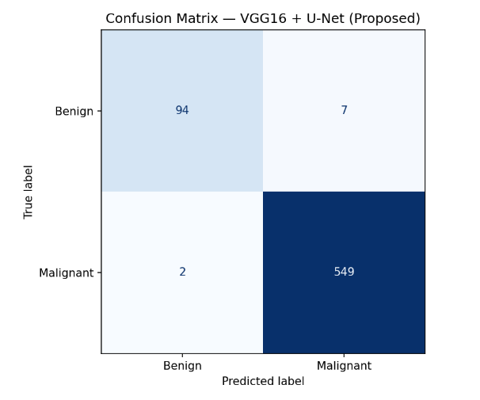
Figure 3. Confusion matrix of the VGG16 + U-Net model

Classification Result - VGG16 with Ground Truth Masks
Prior to classification, the original blood smear images were masked using the manually annotated ground truth segmentation masks instead of the masks predicted by the U-Net model. This configuration was designed as an upper-bound reference to evaluate the maximum classification performance achievable when perfect segmentation masks are available. By eliminating segmentation prediction errors, the experiment enables a clearer assessment of whether any performance differences originate from segmentation quality or from the masking process itself.
The classification results are presented in Table 3. The VGG16 model trained using ground truth masked images achieved an overall accuracy of 98.31% on the test set. The model obtained a precision of 0.94, recall of 0.95, and F1-score of 0.95 for the benign class, while the malignant class achieved precision, recall, and F1-score of 0.99. The model also achieved an AUC-ROC of 0.9972, indicating excellent discriminative capability.

Table 3. Classification Performance of VGG16 with Ground Truth Masks
Class | Precision | Recall | F1-Score | Support
Benign | 0.94 | 0.95 | 0.95 | 101
Malignant | 0.99 | 0.99 | 0.99 | 551
Accuracy | - | - | 0.9831 | 652
Weighted Avg | 0.98 | 0.98 | 0.9831 | 652

The classification performance obtained using ground truth masks remained lower than the baseline VGG16 model trained on the original images. This observation suggests that perfect segmentation alone does not necessarily improve classification performance on this dataset. Instead, the masking process may remove contextual information that contributes to classification. A more detailed interpretation of this finding is presented in the Discussion section.
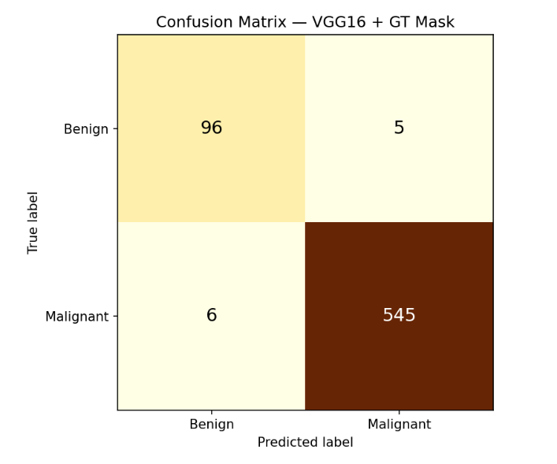
Figure 4. Confusion matrix of the VGG16 with Ground Truth Mask model

Classification Result - VGG16 Baseline
The baseline VGG16 model, trained directly on original images without segmentation (32), achieved a higher performance with an overall accuracy of 99.69% and an AUC-ROC of 0.9999.

Table 4. Classification Performance of VGG16 Baseline
Class | Precision | Recall | F1-Score | Support
Benign | 0.99 | 0.99 | 0.99 | 101
Malignant | 1.00 | 1.00 | 1.00 | 551
Accuracy | - | - | 0.9969 | 652
Weighted Avg | 1.00 | 1.00 | 0.9969 | 652
AUC | 1.00 | 1.00 | 0.9969 | 652

The baseline model produced only 2 misclassifications out of 652 test samples, demonstrating near-perfect classification performance. The confusion matrix indicates a balanced error distribution, with one benign sample misclassified as malignant and one malignant sample misclassified as benign.

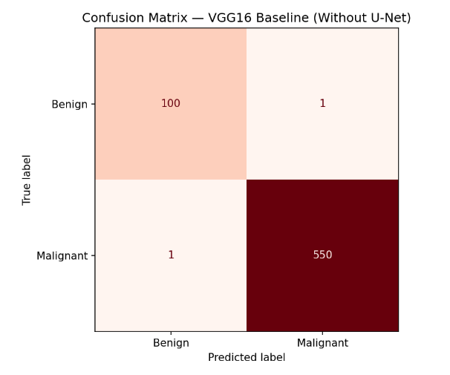
Figure 5. Confusion matrix of the VGG16 baseline model

Comparative Analysis
To evaluate the actual contribution of segmentation in leukemia classification, three VGG16 classification configurations were compared. The first configuration used VGG16 trained directly on original blood smear images as the baseline. The second configuration used VGG16 trained on U-Net segmented blood images, where the original image was multiplied element-wise by the U-Net predicted mask (33). The third configuration used VGG16 trained on ground truth segmented blood images, where the original image was multiplied by the ground truth mask as the upper-bound reference. This comparison directly addresses the core research question of whether WBC segmentation, whether predicted or ground truth, genuinely improves classification of malignant and benign leukemia cells.
The comparative results are presented in Table 5. The VGG16 baseline achieved the highest classification performance with 99.69% accuracy and AUC-ROC of 0.9999, outperforming both segmentation-based configurations. VGG16 trained on U-Net segmented blood images achieved 98.62% accuracy and AUC-ROC of 0.9958, while VGG16 trained on ground truth segmented blood images achieved 98.31% accuracy and AUC-ROC of 0.9972.

Table 5. Comparative Performance of All Models
Model | DSC | IoU | Accuracy | AUC-ROC
U-Net Segmentation | 0.7885 | 0.7134 | - | -
VGG16 Baseline | - | - | 0.9969 | 0.9999
VGG16 + U-Net | - | - | 0.9862 | 0.9958
VGG16 + Ground Truth Mask | - | - | 0.9831 | 0.9972

The most significant finding is that even when using perfect ground truth segmentation masks as input, eliminating all segmentation errors, the resulting classification performance of 98.31% still fell below the baseline model at 99.69%. This definitively demonstrates that the performance gap is not caused by U-Net segmentation imperfection, but rather by the inherent loss of contextual information introduced by the masking process itself. When background regions are suppressed, potentially useful contextual features such as cell density, spatial distribution, and inter-cellular relationships are also removed, which negatively impacts the classifier's discriminative capability.
Furthermore, the fact that VGG16 trained on U-Net segmented images at 98.62% slightly outperformed VGG16 trained on ground truth segmented images at 98.31% further supports this interpretation. The U-Net predicted masks, being imperfect, retain some background information that inadvertently preserves useful contextual cues, whereas the stricter ground truth masks remove more background, resulting in greater information loss. This counter-intuitive finding reinforces the conclusion that for datasets with high visual separability between benign and malignant cells, segmentation does not provide meaningful benefit and may instead reduce classification performance by eliminating contextually relevant information.
Deep convolutional networks such as VGG16 are capable of learning hierarchical features (34), including implicit localization of relevant regions through attention-like mechanisms. This internal localization capability reduces the dependency on explicit segmentation, especially when morphological differences between classes are already visually prominent in the original images.

ROC Curve Analysis
The ROC curves of the three classification models are presented in Figure 6. All models achieved excellent discriminative performance, as indicated by ROC curves approaching the upper-left corner. The baseline VGG16 model achieved the highest AUC-ROC (0.9999), followed by VGG16 with Ground Truth Masks (0.9972) and VGG16 with U-Net Masks (0.9958). Although all three models demonstrated outstanding discrimination between benign and malignant samples, the baseline model consistently achieved the best performance.
The slightly higher performance of the Ground Truth Mask model compared with the U-Net Mask model suggests that improved segmentation quality can reduce the impact of segmentation errors. However, even with perfect segmentation masks, the classification performance remained lower than that of the baseline model trained on the original images. This observation indicates that removing background regions does not necessarily improve classification performance for the ALL dataset. Instead, the original images appear to contain contextual information that contributes to the discriminative capability of the VGG16 classifier. These findings further support the conclusion that explicit segmentation is not a prerequisite for achieving high leukemia classification performance on datasets with strong visual separability
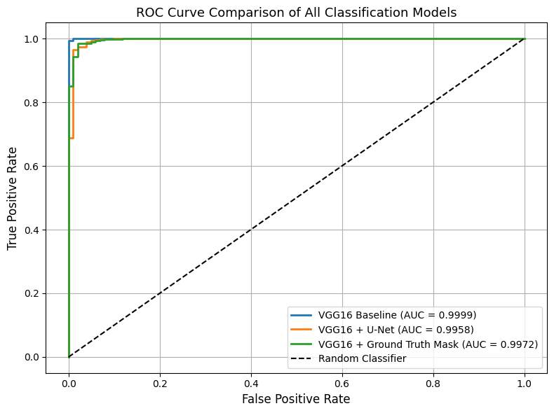
Figure 6. ROC Curve Comparison of All Classification Models

DISCUSSION
The most notable finding of this study is that the baseline VGG16 model without segmentation consistently outperformed both segmentation-based configurations, including the pipeline using ground truth masks as the upper-bound reference. This result appears counter-intuitive because segmentation is generally expected to improve classification by removing irrelevant background information. Therefore, this section discusses the experimental observations that may explain this finding.
The dataset used in this study is the ALL-Kaggle dataset, which exhibits exceptionally high visual separability between benign and malignant cell classes. This characteristic was verified through the baseline model's near-perfect performance of 99.69% accuracy and AUC-ROC of 0.9999, achieved without any segmentation preprocessing. The malignant cells display distinct morphological characteristics such as irregular nuclei, altered nuclear-to-cytoplasmic ratios, and chromatin abnormalities that are clearly visible in the original images. Under these conditions, the VGG16 model with transfer learning is already capable of capturing sufficient discriminative features directly from the original images, reducing the potential benefit of explicit segmentation for this particular dataset. It should be noted that the extremely high baseline performance (99.69% accuracy) indicates that the findings regarding the limited benefit of explicit segmentation may not fully generalize to more challenging or heterogeneous leukemia datasets. To ensure a fair comparison, all three classification configurations were trained and evaluated using identical training, validation, and testing splits. The only difference among the models was the input representation, namely original images, U-Net-predicted masked images, and ground truth masked images.
The additional experiment using ground truth masks provides further evidence that the observed performance degradation is not solely caused by segmentation errors, but is also influenced by the loss of contextual information introduced during masking. Although the ground truth masks contain no prediction errors, the VGG16 model trained on these perfectly segmented images achieved an accuracy of 98.31%, which was still lower than the baseline VGG16 trained on the original images (99.69%). This finding suggests that the masking process may remove contextual information that contributes to classification performance. When the background is suppressed, contextual features such as cell density, spatial distribution of erythrocytes, and inter-cellular spatial relationships are also removed. These contextual cues, while not directly related to individual cell morphology, appear to provide useful discriminative information that the VGG16 model leverages when classifying the original images.
Interestingly, VGG16 trained on U-Net segmented images achieved a slightly higher accuracy (98.62%) than VGG16 trained on ground truth segmented images (98.31%). One possible explanation is that the imperfect U-Net masks may retain a limited amount of background information, thereby preserving contextual cues that are removed by the stricter ground truth masks. Consequently, the ground truth masks may eliminate not only irrelevant background regions but also contextual information that contributes to classification performance. Although this interpretation requires further investigation, the result further suggests that background context may play a beneficial role in leukemia classification on this dataset.
Regarding segmentation errors, of the 9 misclassified samples in the VGG16 plus U-Net pipeline, 5 were associated with imperfect U-Net mask outputs, particularly in images where WBC regions were sparse or partially occluded by overlapping erythrocytes. These cases demonstrate that segmentation errors can propagate into the classification stage and negatively affect prediction outcomes. However, given that even perfect segmentation in the ground truth configuration still underperformed the baseline, error propagation is a secondary rather than primary factor explaining the overall performance gap.
Although segmentation did not improve classification performance, it offers an important advantage in terms of clinical interpretability. The segmentation masks provide explicit localization of white blood cell regions, enabling clinicians to visually validate the model's focus area and cross-reference with their domain expertise. This explainability property is critical for adoption in clinical settings, where black-box decisions are not acceptable. Furthermore, the segmented cell images may facilitate downstream clinical tasks such as cell morphology quantification and leukemia subtype characterization, providing diagnostic value beyond binary classification.
From a practical perspective, the proposed segmentation-classification pipeline can support pathologists in resource-limited laboratories by providing visual localization of abnormal white blood cells, thereby reducing examination time and inter-observer variability. Although the baseline model achieved higher classification accuracy, the inclusion of explicit segmentation offers greater transparency, which is essential for building clinician trust and facilitating regulatory acceptance of AI-assisted diagnostic tools. In clinical workflows, the segmented outputs may also serve as a preliminary screening aid, allowing medical personnel to prioritize cases that require closer examination.

CONCLUSION
This study evaluated the contribution of U-Net-based segmentation to leukemia classification by comparing three deep learning (36) configurations: VGG16 trained on original images (baseline), VGG16 trained on U-Net-predicted segmented images, and VGG16 trained on ground truth segmented images. The U-Net model achieved satisfactory segmentation performance, obtaining a Dice Similarity Coefficient (DSC) of 0.7885 and an Intersection over Union (IoU) of 0.7134, demonstrating its capability to localize white blood cell regions effectively.
Experimental results showed that the baseline VGG16 model trained on the original images achieved the highest classification performance, with an accuracy of 99.69% and an AUC-ROC of 0.9999. In comparison, VGG16 trained on U-Net segmented images achieved an accuracy of 98.62% and an AUC-ROC of 0.9958, while VGG16 trained on ground truth segmented images achieved an accuracy of 98.31%. These findings indicate that explicit segmentation did not improve classification performance for the ALL-Kaggle dataset, where the original microscopic images already provide highly discriminative visual features.
Although segmentation did not improve classification accuracy, it offers an important advantage in terms of clinical interpretability by explicitly localizing white blood cell regions, thereby facilitating visual validation of the model's focus area. Consequently, the adoption of segmentation should be determined by the characteristics of the dataset and the intended clinical application rather than being assumed to universally improve classification performance.
This study has several limitations. First, the dataset was obtained from a single publicly available source with a fixed image resolution and staining protocol, which may limit the generalizability of the findings to images acquired under different clinical settings. Second, the classification task was formulated as a binary problem (benign versus malignant), without distinguishing among the malignant subtypes (Early, Pre, and Pro). Third, the segmentation performance was affected by several test images containing minimal or absent white blood cell regions, resulting in moderate segmentation accuracy. Finally, computational limitations restricted extensive hyperparameter optimization and cross-validation across multiple data splits, which may influence the robustness of the reported performance.
Future work should investigate more heterogeneous leukemia datasets, evaluate advanced segmentation architectures such as Attention U-Net or U-Net++, and explore hybrid approaches that preserve both cellular morphology and contextual information. Such investigations may provide a deeper understanding of when segmentation can meaningfully contribute to medical image classification.

ACKNOWLEDGMENTS
The authors would like to thank Universitas Duta Bangsa Surakarta for the facilities and resources provided during this research. The authors also express their gratitude to all parties who have contributed to the research and the writing of this article.

REFERENCES
1. Shah A, Naqvi SS, Naveed K. Automated Diagnosis of Leukemia : A Comprehensive Review. IEEE Access. 2021;9:132097–124.
2. Saleem S, Amin J, Sharif M, Almas M, Muhammad A, Wang SH. A deep network designed for segmentation and classification of leukemia using fusion of the transfer learning models. Complex Intell Syst [Internet]. 2022;8(4):3105–20. Available from: https://doi.org/10.1007/s40747-021-00473-z
3. Tamas L, Bușoniu L. A reliable approach for identifying acute lymphoblastic leukemia in microscopic imaging. 2025;(July):1–14.
4. Leukemia CNMC. Machine learning in detection and classification of leukemia. Multimed Tools Appl [Internet]. 2024;83(3):8063–76. Available from: https://doi.org/10.1007/s11042-023-15923-8
5. Alsaykhan LK, Maashi MS. OPEN A hybrid detection model for acute lymphocytic leukemia using support vector machine and particle swarm optimization ( SVM- PSO ). 2024;
6. Sharma S, Guleria K, Tiwari S, Kumar S. Measurement : Sensors A deep learning based convolutional neural network model with VGG16 feature extractor for the detection of Alzheimer Disease using MRI scans. Meas Sensors [Internet]. 2022;24(September):100506. Available from: https://doi.org/10.1016/j.measen.2022.100506
7. Nadeu F, Royo R, Massoni-badosa R, Playa-albinyana H, Garcia-torre B, Duran-ferrer M, et al. transformation in chronic lymphocytic leukemia. 2022;28(August).
8. Alatawi AA, Alomani SM, Alhawiti NI, Ayaz M. Plant Disease Detection using AI based VGG-16 Model. 2022;13(4):718–28.
9. Farangis R, Kizi O, Poupi T, Armand T, Kim H cheol. A Review of Deep Learning Techniques for Leukemia Cancer Classification Based on Blood Smear Images. 2025;
10. Hasanaath AA, Mohammed AS, Latif G, Abdelhamid SE. Acute lymphoblastic leukemia detection using ensemble features from multiple deep CNN models. 2024;32(March):2407–23.
11. Shafique S, Tehsin S. Acute Lymphoblastic Leukemia Detection and Classification of Its Subtypes Using Pretrained Deep Convolutional Neural Networks. 2018;17:1–7.
12. Kamath A, Willmann J, Andratschke N, Reyes M. The impact of U-Net architecture choices and skip connections on the robustness of segmentation across texture variations. Comput Biol Med [Internet]. 2025;197(PB):111056. Available from: https://doi.org/10.1016/j.compbiomed.2025.111056
13. Kadry S, Rajinikanth V, Taniar D. Automated segmentation of leukocyte from hematological images — a study using various CNN schemes. J Supercomput [Internet]. 2022;78(5):6974–94. Available from: https://doi.org/10.1007/s11227-021-04125-4
14. Rafi A, Hutomo R. Segmentasi dan Penghitungan Otomatis Sel Darah Merah pada Citra Mikroskopis Menggunakan Transformasi Watershed Berbasis Kanal Saturasi. 2026;1–6.
15. Ghaderzadeh M, Asadi F, Hosseini A, Bashash D, Abolghasemi H, Roshanpour A. Machine Learning in Detection and Classification of Leukemia Using Smear Blood Images : A Systematic Review. 2021;2021.
16. Song Z, Fu L, Wu J, Liu Z, Li R, Cui Y. Kiwifruit detection in field images using Faster R-CNN with VGG16 Kiwifruit detection in field images using Faster R-CNN with VGG16 Kiwifruit detection in field images using Faster R-CNN with VGG16. IFAC Pap [Internet]. 2019;52(30):76–81. Available from: https://doi.org/10.1016/j.ifacol.2019.12.500
17. Hasanah AN, Sas O Al, Kosen YD. APPLICATION OF ARTIFICIAL INTELLIGENCE IN WHITE BLOOD CELL CLASSIFICATION BASED ON MICROSCOPIC IMAGES : A SCOPING REVIEW. 2025;18(2):124–31.
18. Mohan SB, Sathya S, Rajalakshmi S, Gurumoorthy G, Sivanraju R. Efficient convolutional neural networks for acute lymphoblastic leukaemia prediction in computer vision. 2026;1–15.
19. Anemia KJ jenis, Priandika A, Isnain AR. Application of Ensemble Learning Technique for Classification of Anemia Types Penerapan Teknik Ensemble Learning untuk. 2025;5(July):972–80.
20. Mara UT, Mara UT. Color Image Enhancement of Acute Leukemia Cells in Blood Microscopic Image for Leukemia Detection Sample. 2020;(3):24–9.
21. Raj R, Paliwal S, Meena G, Raj R, Raj R. ScienceDirect on Machine Learning using Image Forgery Detection System UNET Model Image Detection System using VGG16 UNET Model a VGG16 UNET Image Forgery Forgery Detection using Model Choudhary System. Procedia Comput Sci [Internet]. 2024;235:735–44. Available from: https://doi.org/10.1016/j.procs.2024.04.070
22. Williams C, Falck F, Deligiannidis G, Holmes C, Doucet A, Syed S. A Unified Framework for U-Net Design and Analysis. 2023;(NeurIPS):1–38.
23. Shah SR, Qadri S, Bibi H, Muhammad S, Shah W, Sharif MI, et al. 50 : A Case Study on Early Detection of a Rice Disease. 2023;1–13.
24. Aria, Mehrad; Ghaderzadeh, Mustafa; Bashash, Davood; Abolghasemi, Hassan; Asadi, Farkhondeh; Hosseini A. Acute Lymphoblastic Leukemia (ALL) image dataset [Internet]. Kaggle; 2021. Available from: https://www.kaggle.com/dsv/2175623
25. Aydin Atasoy, Nesrin; Faris Abdulla Al Rahhawi A. Examining the classification performance of pre-trained capsule networks on imbalanced bone marrow cell dataset. Int J Imaging Syst Technol. 2024;34(3):e23067.
26. Qu Z, Mei J, Liu L, Zhou D yang. Crack Detection of Concrete Pavement With Cross-Entropy Loss Function and Improved VGG16 Network Model. IEEE Access. 2020;8:54564–73.
27. Nasir MU, Khan MF, Khan MA, Zubair M, Abbas S, Alharbi M. Hematologic Cancer Detection Using White Blood Cancerous Cells Empowered with Transfer Learning and Image Processing. 2023;2023.
28. Alagu S, N AP, Kavitha G, K BB. Automatic Detection of Acute Lymphoblastic Leukemia Using UNET Based Segmentation and Statistical Analysis of Fused Deep Features. Appl Artif Intell [Internet]. 2021;00(00):1–18. Available from: https://doi.org/10.1080/08839514.2021.1995974
29. Yang H, Ni J, Gao J, Han Z, Luan T. OPEN A novel method for peanut variety identification and classification by Improved VGG16. Sci Rep [Internet]. 2021;1–17. Available from: https://doi.org/10.1038/s41598-021-95240-y
30. Pardede J. Implementation of Transfer Learning Using VGG16 on Fruit Ripeness Detection. 2021;(April):52–61.
31. Mohammad N, Azam M, Raiaan K, Ittesafun A. Biomedical Engineering Advances Advanced biomedical imaging for identifying blood cell type : Integrating segmentation , feature extraction , and GraphSAGE model. Biomed Eng Adv [Internet]. 2025;9(May):100174. Available from: https://doi.org/10.1016/j.bea.2025.100174
32. Zan X, Zhang X, Xing Z, Liu W, Zhang X, Liu Z, et al. Automatic Detection of Maize Tassels from UAV Images by Combining Random Forest Classifier. 2020;1–17.
33. Asghar R, Kumar S, Shaukat A, Id PH. Classification of white blood cells ( leucocytes ) from blood smear imagery using machine and deep learning models : A global scoping review. 2024;1–25. Available from: http://dx.doi.org/10.1371/journal.pone.0292026
34. Jiang Z peng, Liu Y yang, Shao Z en, Huang K wei. applied sciences An Improved VGG16 Model for Pneumonia Image Classification. 2021;
35. Narayanan KL, Krishnan RS, Robinson YH, Vimal S, Rashid TA, Kaushal C, et al. Measurement : Sensors Enhancing acute leukemia classification through hybrid fuzzy C means and random forest methods. 2025;39(April).
36. Faiz M, Gari B. Deep and Machine Learning for Acute Lymphoblastic Leukemia Diagnosis : A Comprehensive Review. 2024;13:1–24.

